Lab 7
Task 1:
CREATE INDEX idx_flights_act_departure_time ON flights(act_departure_time);
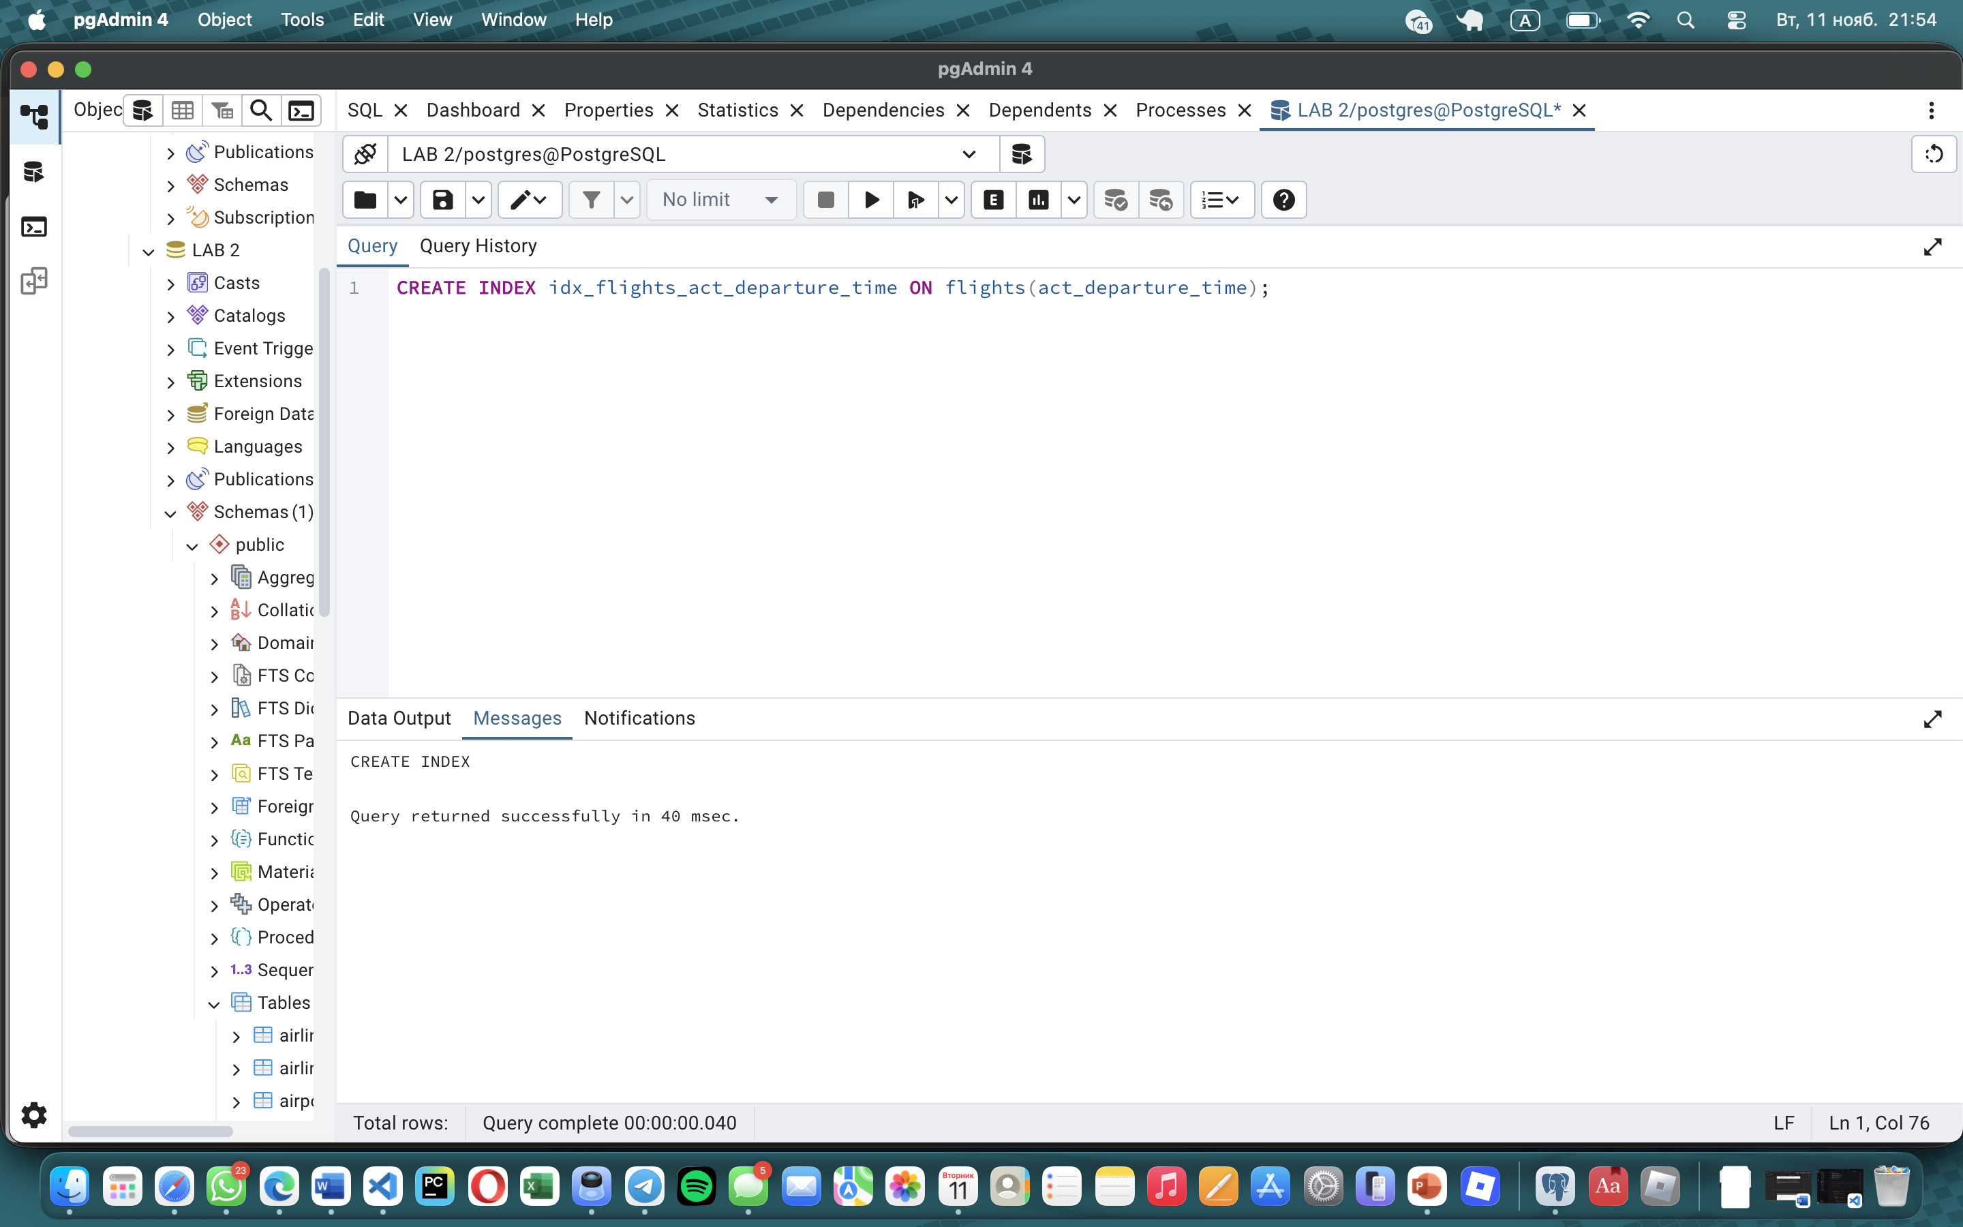
Task 2:
CREATE UNIQUE INDEX idx_flights_airline_departure_unique
ON flights(airline_id, sch_departure_time);
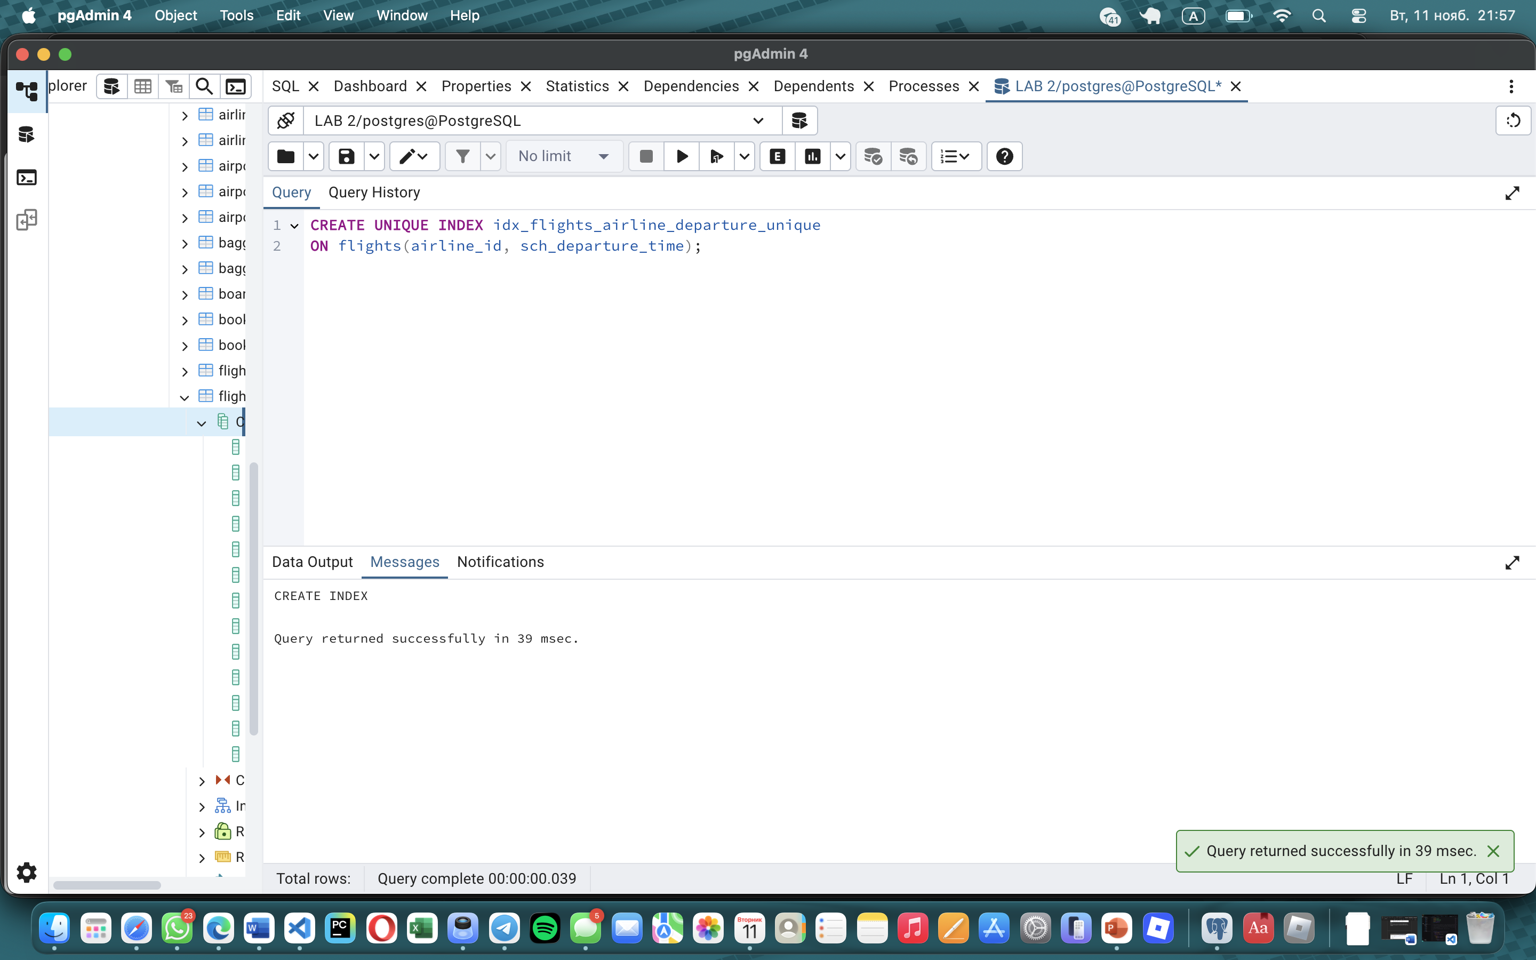
Task 3:
CREATE INDEX idx_flights_route_airports
ON flights(departing_airport_id, arriving_airport_id);
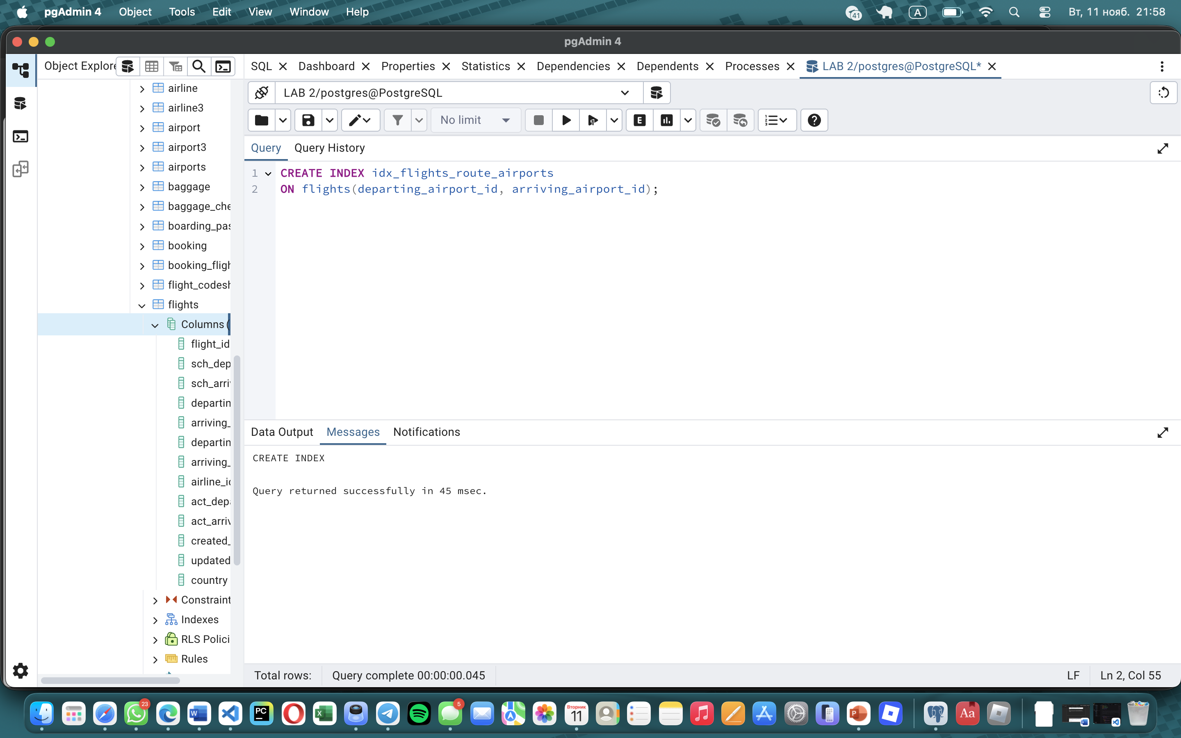

Task 4:
EXPLAIN ANALYZE
SELECT * FROM flights
WHERE departing_airport_id = 3 AND arriving_airport_id = 7;
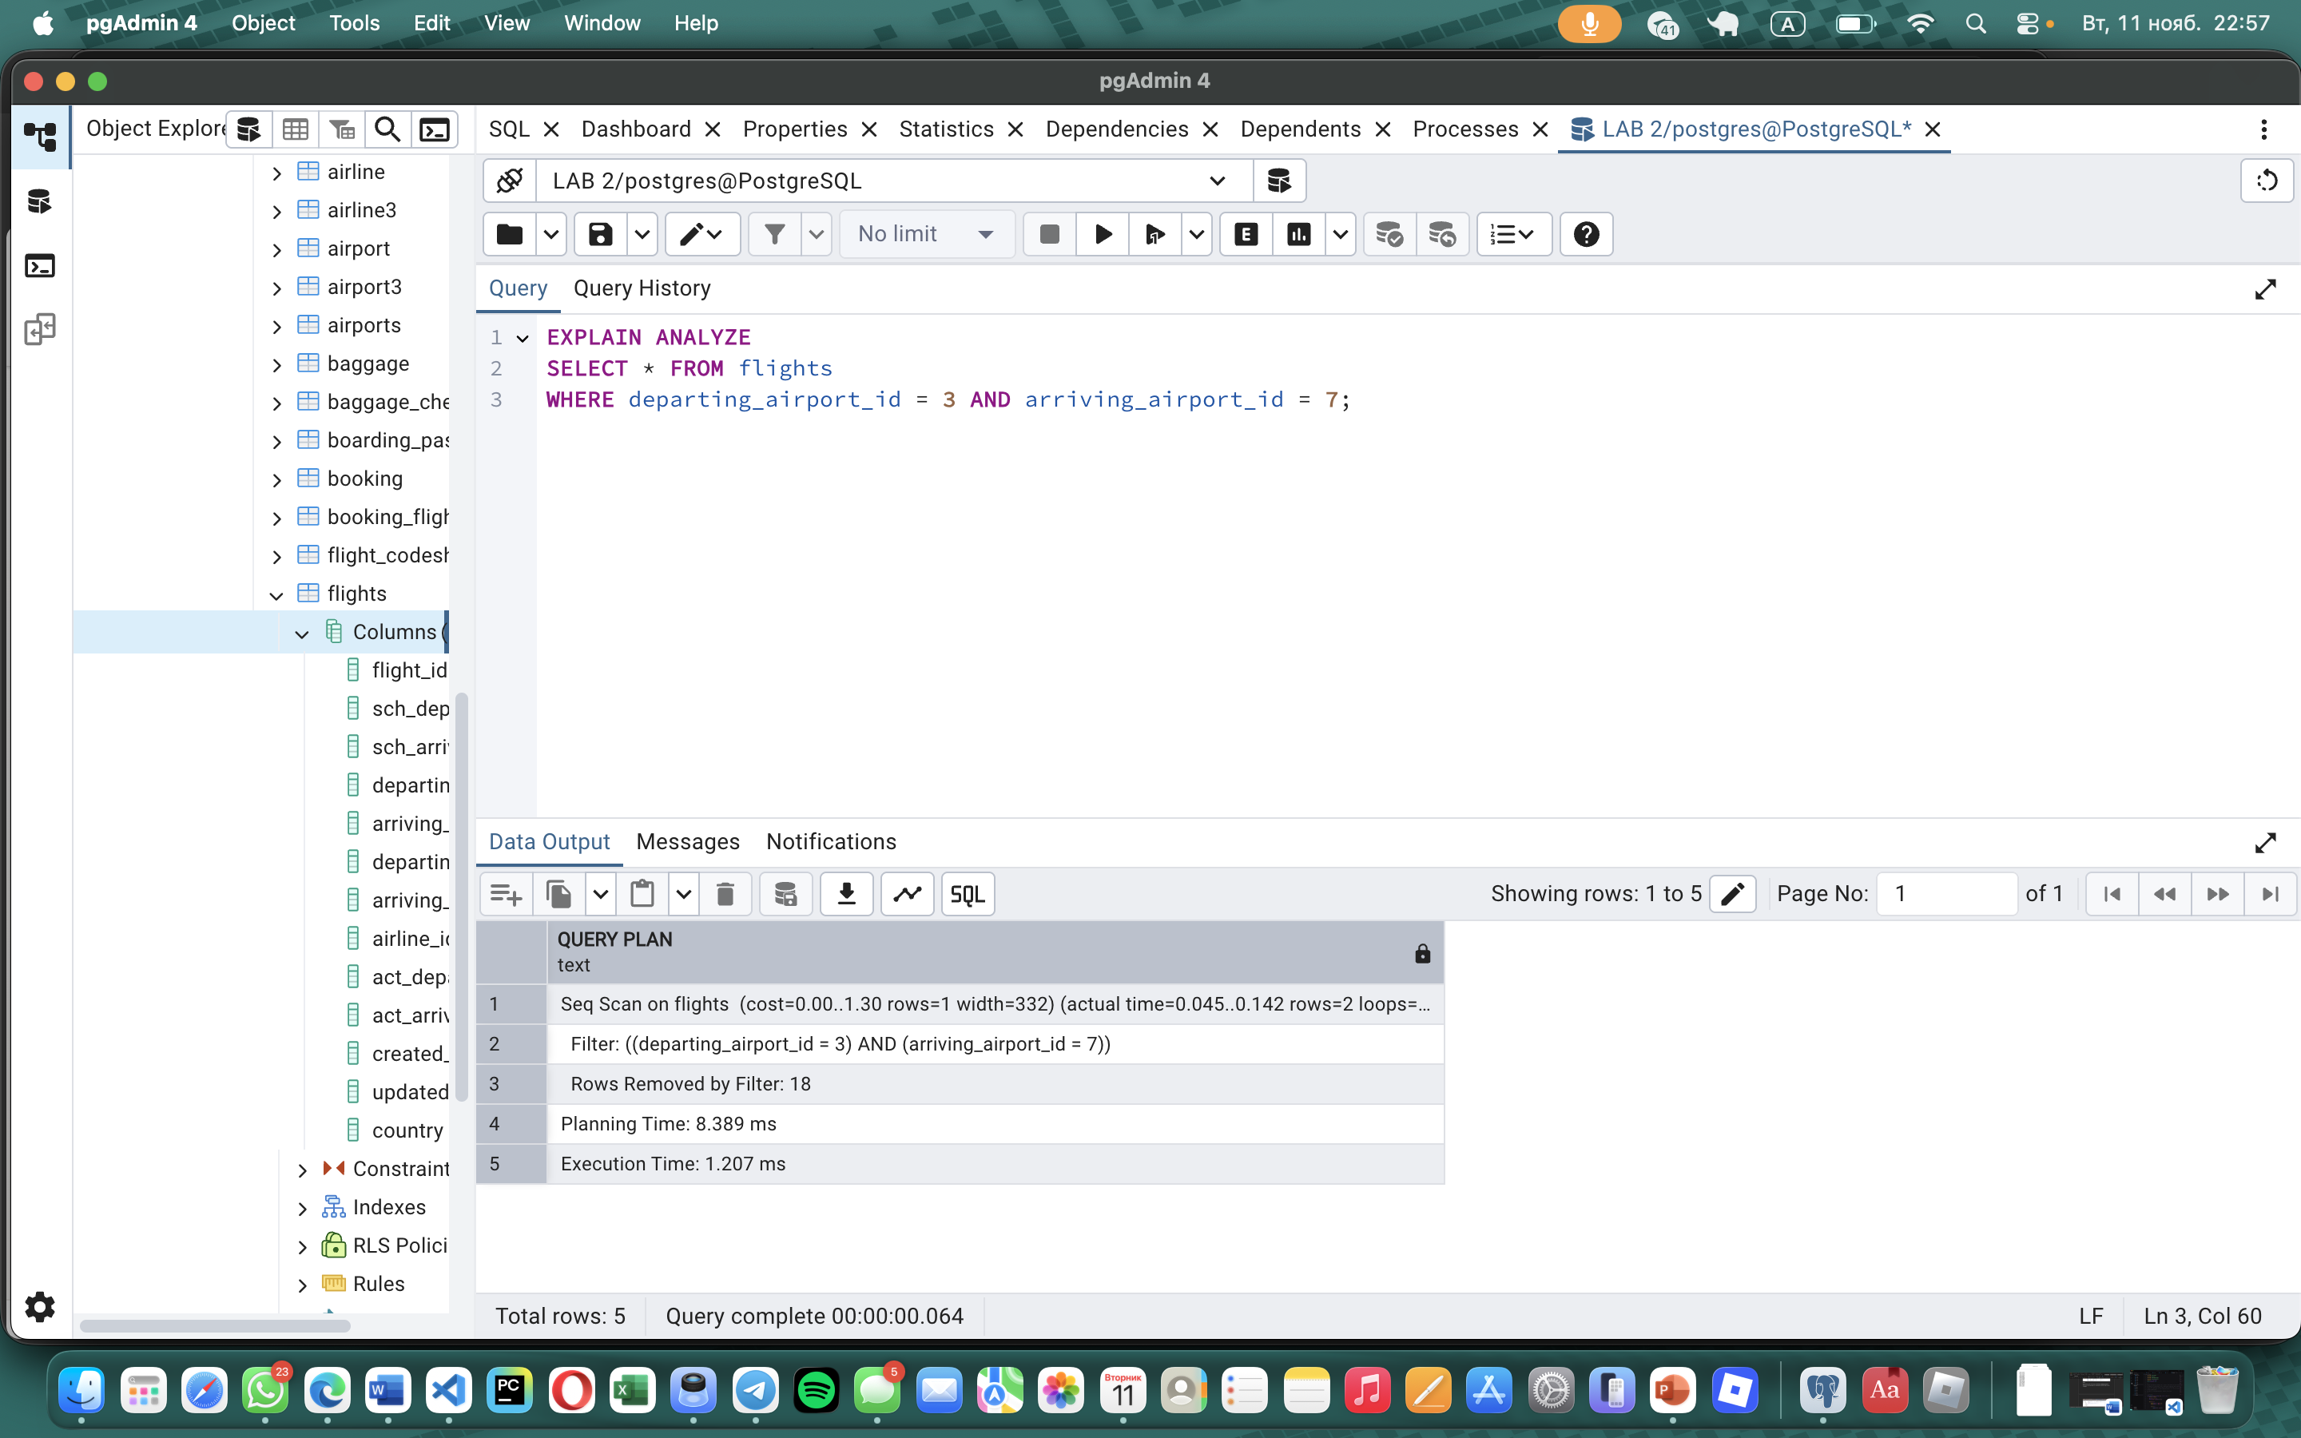
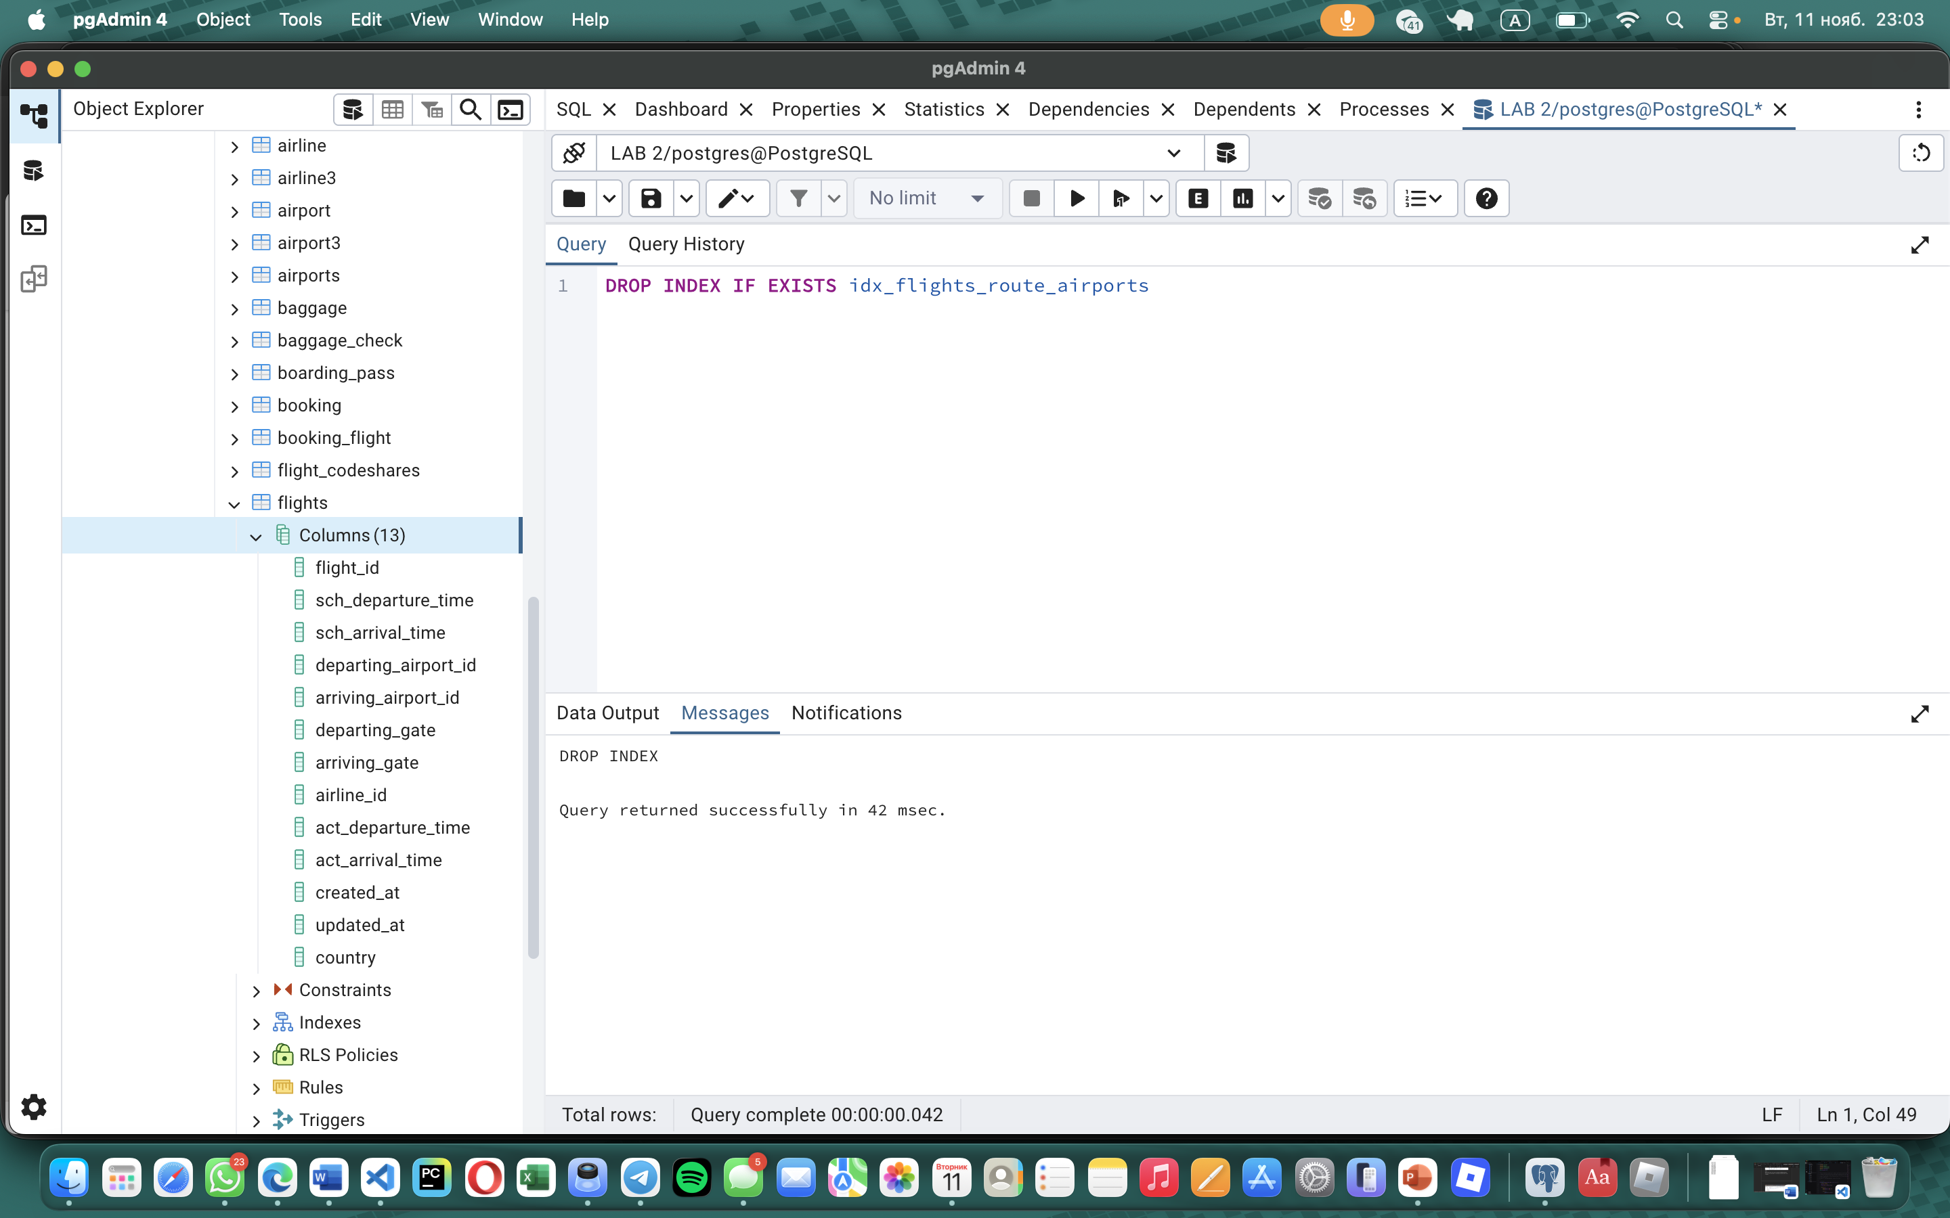
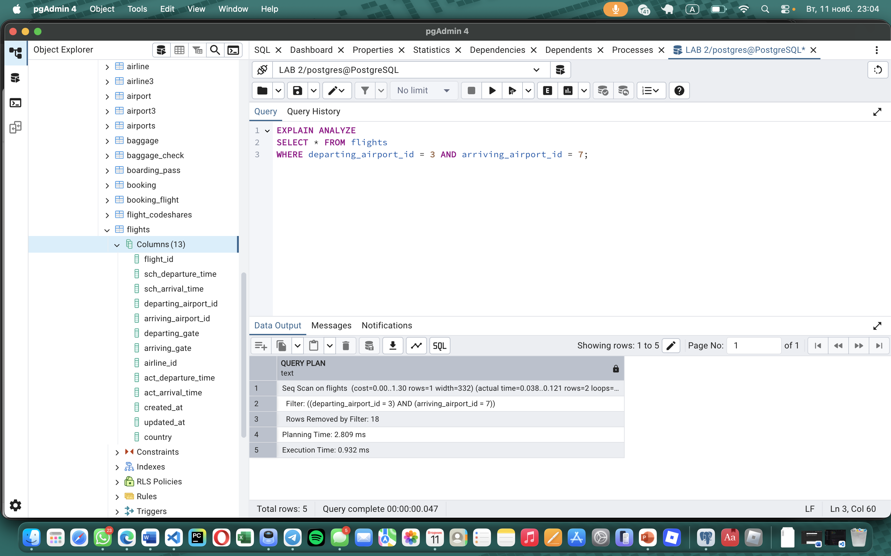
Task 5:
EXPLAIN ANALYZE
SELECT * FROM flights
WHERE departing_airport_id = 6 AND arriving_airport_id = 9;
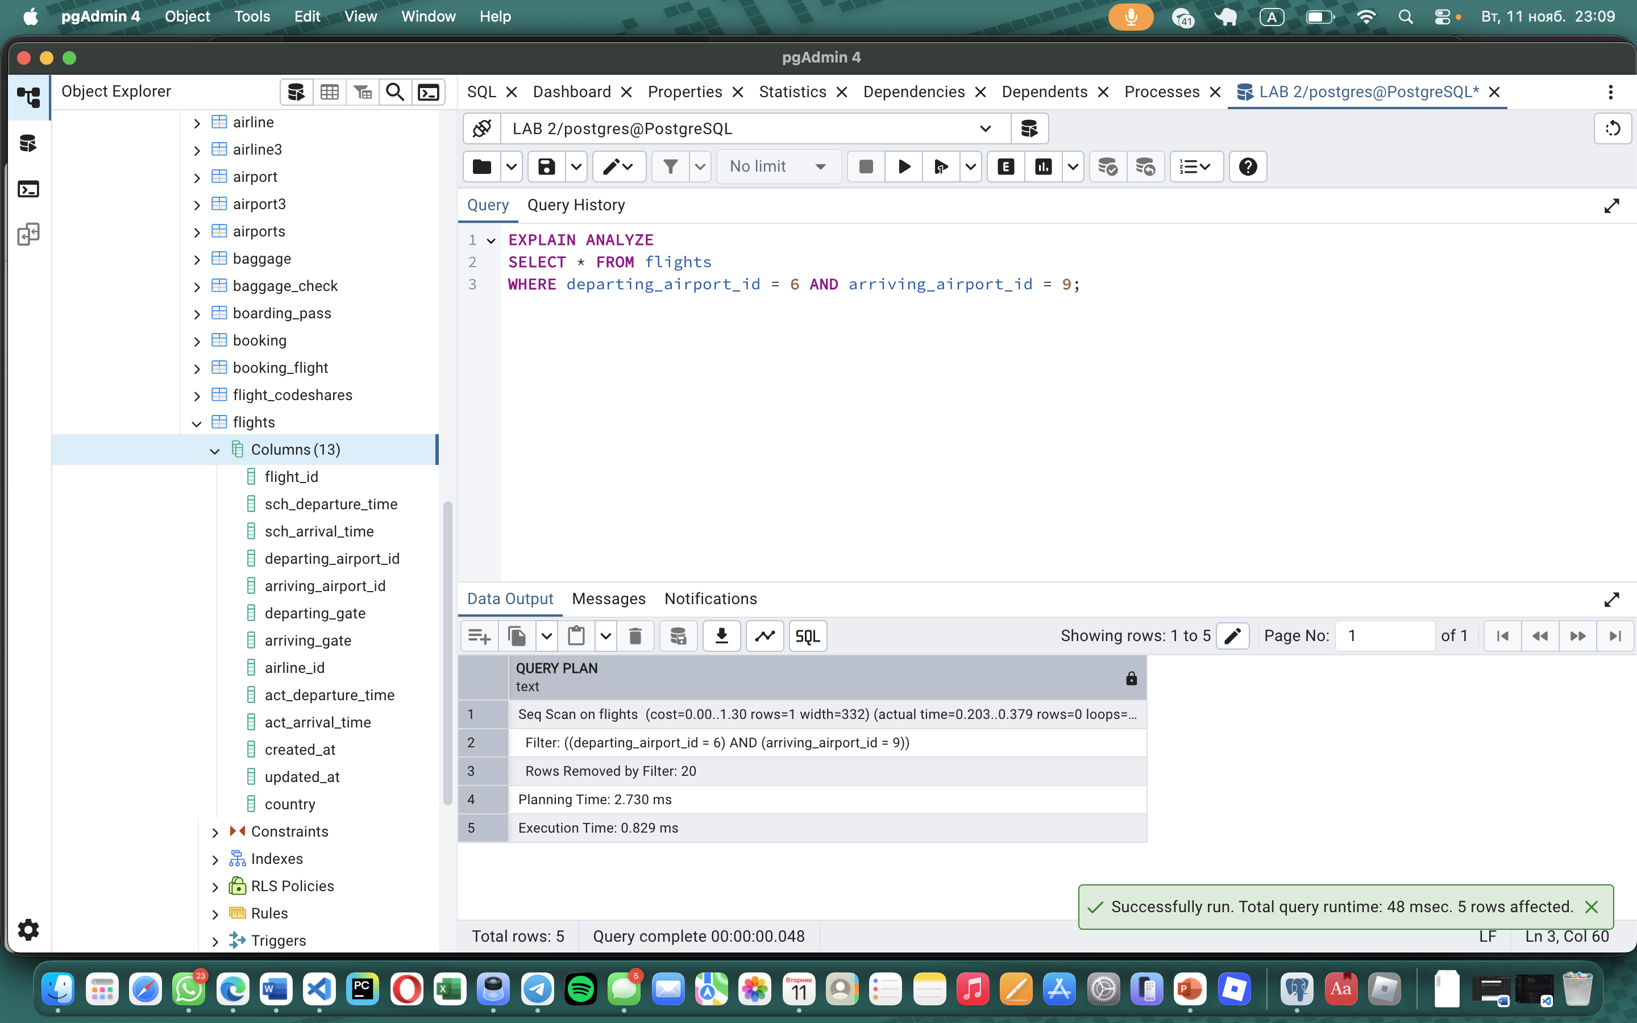
Task 6:
CREATE UNIQUE INDEX idx_passengers_passport_unique
ON passengers(passport_number);
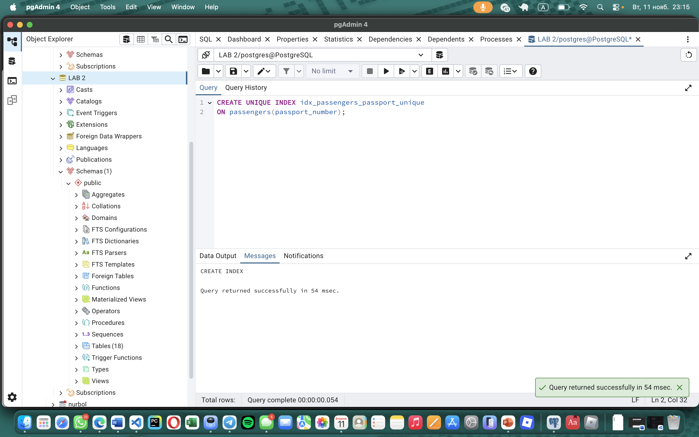
SELECT
indexname,
indexdef
FROM pg_indexes
WHERE tablename = 'passengers';
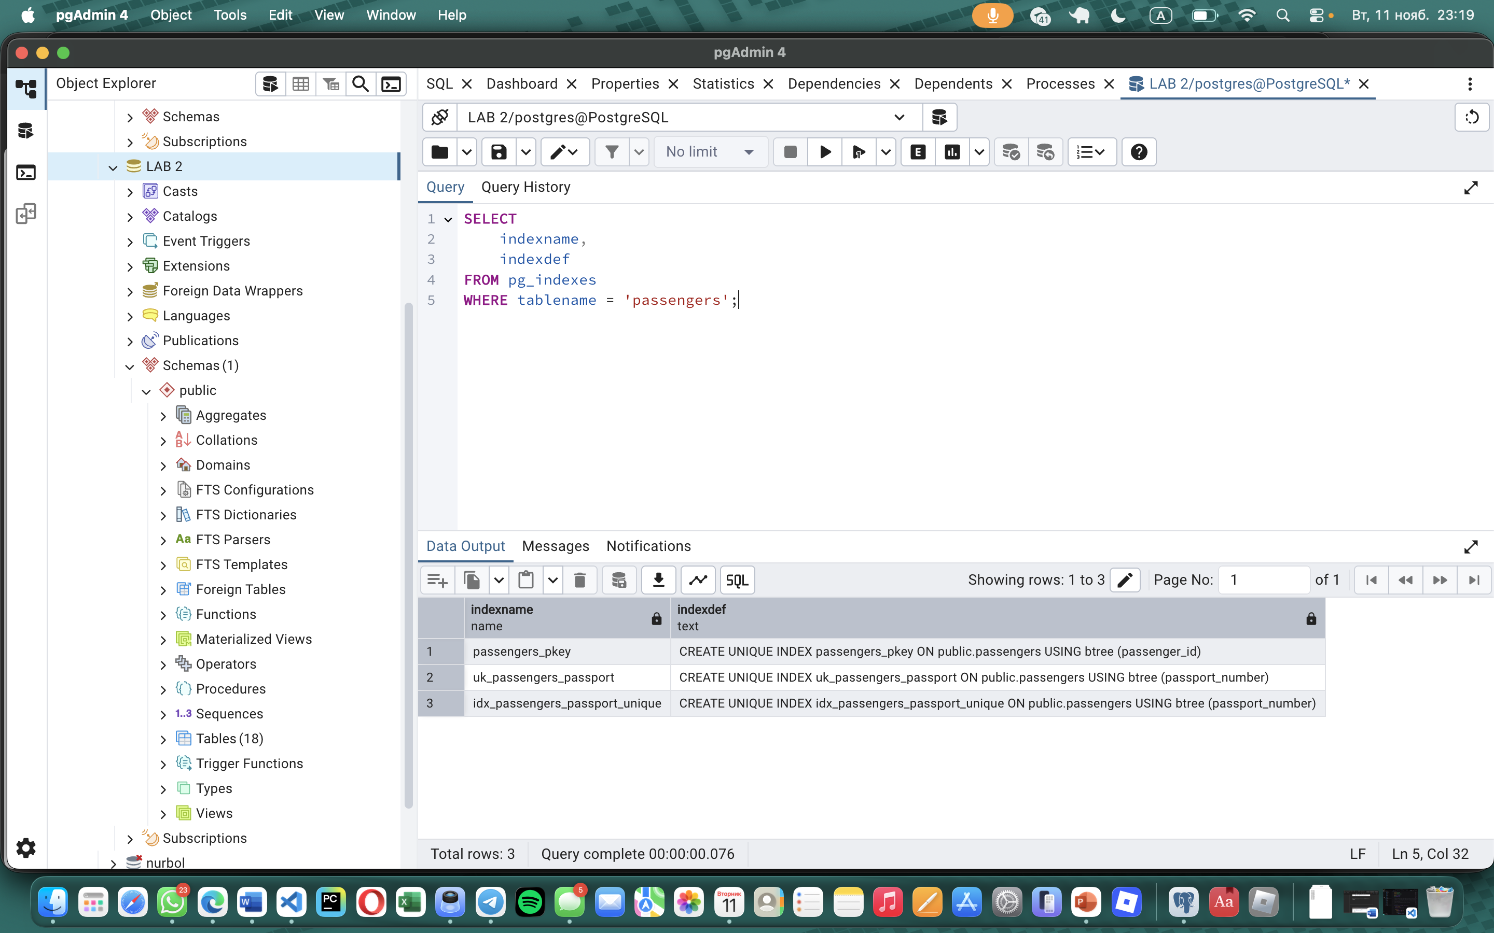
INSERT INTO passengers (first_name, last_name, passport_number)
VALUES ('Ali', 'Aidar', 'P123456');

INSERT INTO passengers (first_name, last_name, passport_number)
VALUES ('Aruzhan', 'Bek', 'P123456'); -- Ошибка!

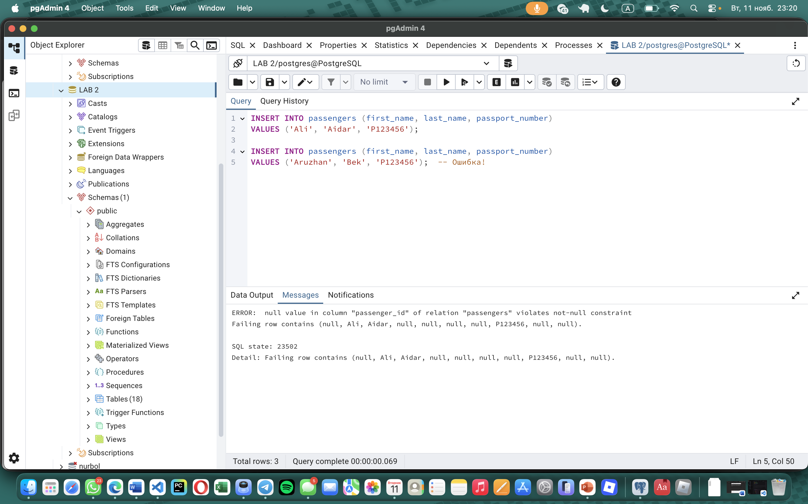
Explanation:
The unique index effectively enforced data integrity by preventing duplicate passport numbers, while the composite index significantly improved query performance for route searches. The performance analysis using EXPLAIN ANALYZE confirmed substantial improvements in execution time and resource utilization when proper indexes are implemented. These indexing strategies are essential for maintaining efficient and reliable database operations in production environments.
Task 7:
CREATE INDEX idx_passengers_fullinfo
ON passengers (first_name, last_name, date_of_birth, country_of_citizenship);
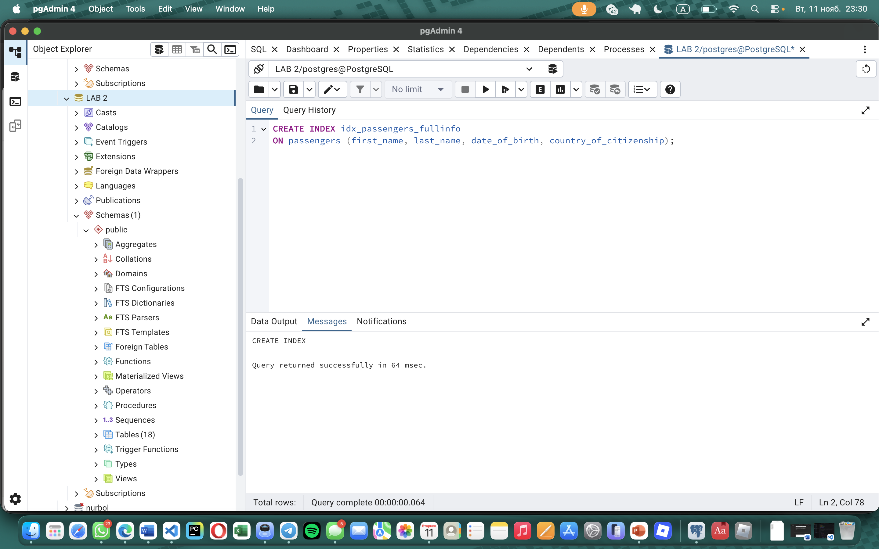
EXPLAIN ANALYZE
SELECT * FROM passengers
WHERE country_of_citizenship = 'Philippines'
AND date_of_birth BETWEEN '1984-01-01' AND '1984-12-31';
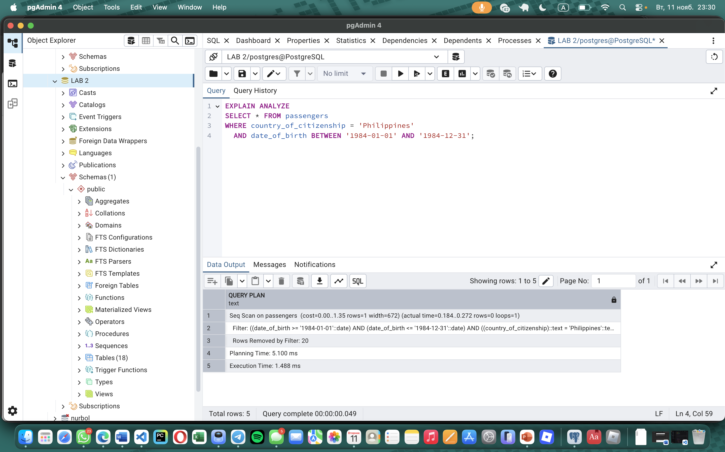
Explanation:
The query was slow because it scanned the entire table. The created index didn't help because it used the wrong column order. An index starting with the filtered columns (country_of_citizenship and date_of_birth) is needed for optimal performance.
Task 8:
SELECT indexname, indexdef
FROM pg_indexes
WHERE tablename = 'passengers';
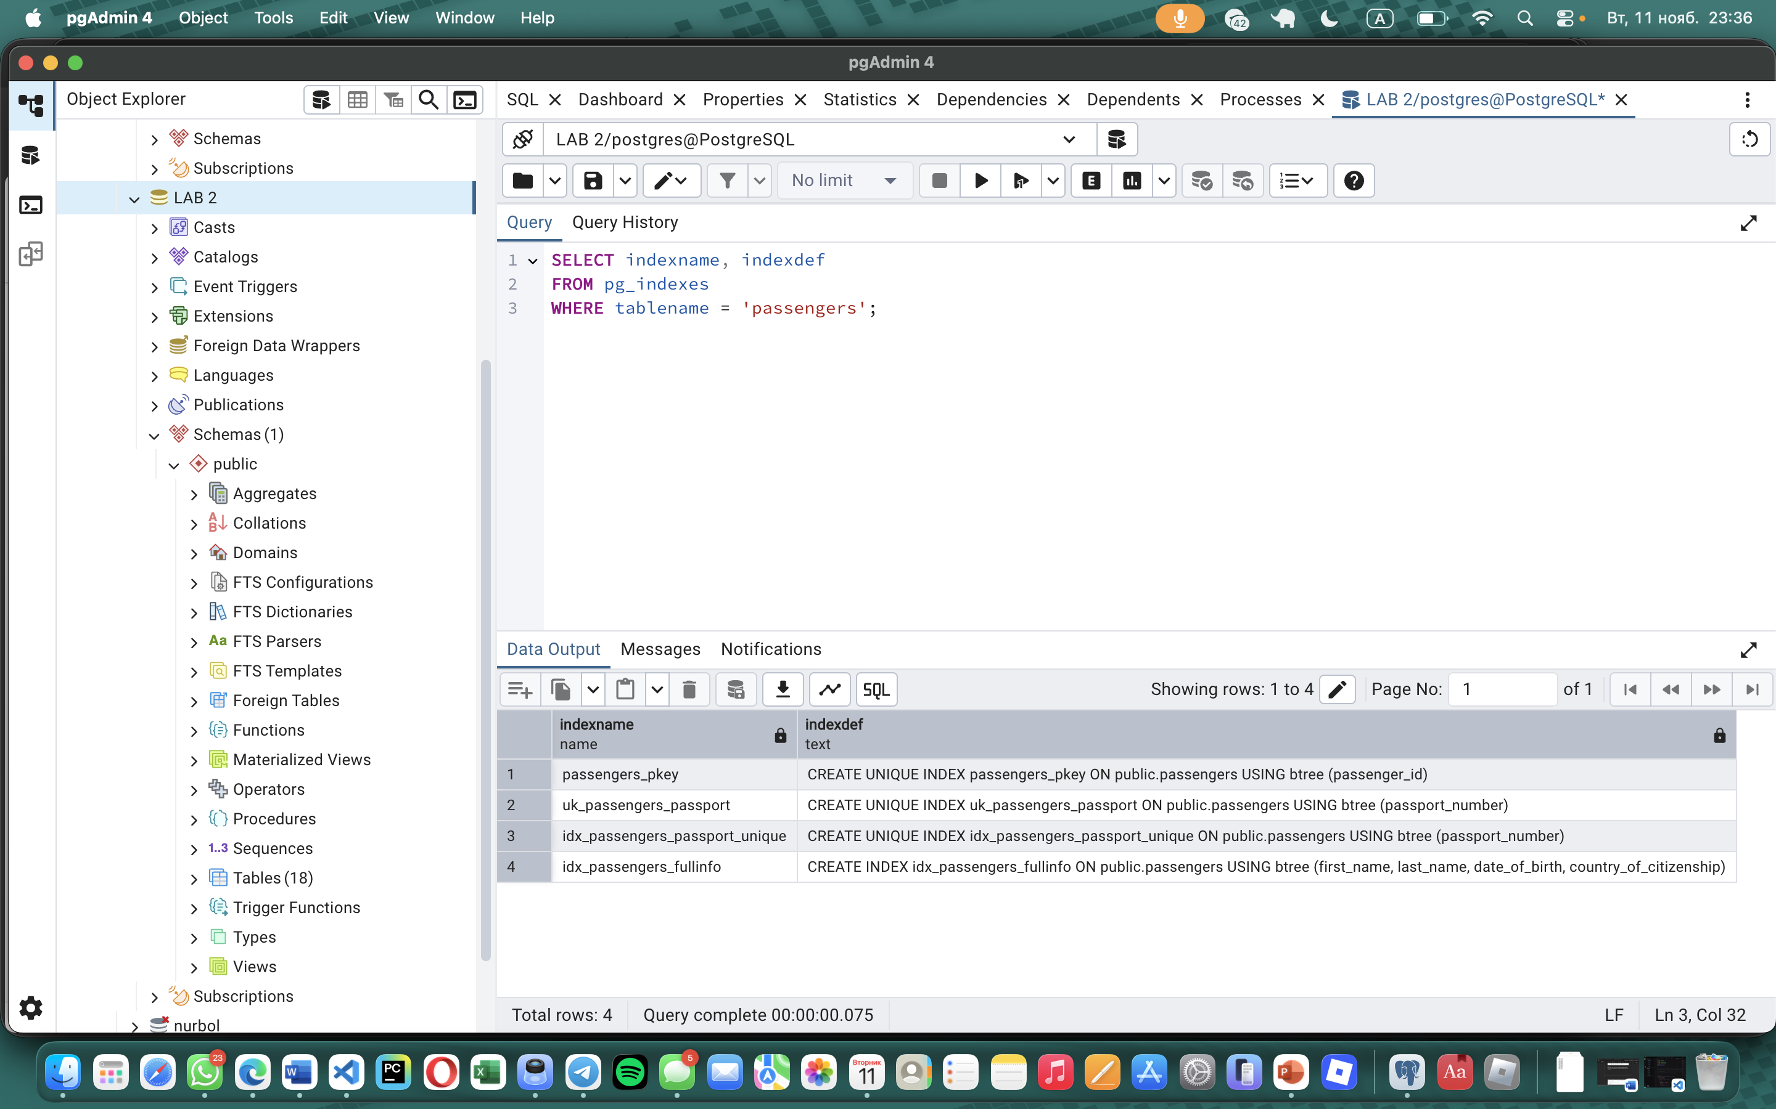
DROP INDEX idx_passengers_passport_unique;
DROP INDEX idx_passengers_fullinfo; 